CHG-MERIDIAN continues to generate profitable growth in 2017

- Increased: Volume of lease originations rises by 8 percent year on year
- Successful: Technology diversification and international positioning pay off
- Innovative: Digitalization offers further opportunities for profitable growth

Weingarten, March 22, 2018
CHG-MERIDIAN, a specialist in non-captive technology management and financing, can look back on yet another positive fiscal year. The Company is headquartered in Weingarten, Germany, and has more than 35 sites in 22 countries. In 2017, it generated lease originations of €1.244 billion, an increase of 8 percent (2016: €1.155 billion). At €57 million, net income was at roughly the same level as in the previous year (2016: €58 million). Profit before taxes amounted to €87 million, which was just over 4 percent above the prior-year figure (2016: €83 million).
“Because our customers are taking greater advantage of digitalization in IT, industrial technologies, and healthcare technologies, we have been able to again achieve strong and profitable growth in 2017,” said Dr. Mathias Wagner, Chairman of the Board of Management of CHG-MERIDIAN, at the annual press conference.

CHG-MERIDIAN has strong business relationships with more than 70 funding partners in 21 countries. The volume of external funding arranged in 2017 totaled €1 billion, of which €155 million was successfully placed in the capital markets in the form of bonded loans and syndicated loans. This meant a further improvement in funding terms compared with 2016.

Successful: Diversification pays off

Under its corporate strategy, CHG-MERIDIAN focuses not just on IT but also on industrial and healthcare technologies, all delivered an encouraging performance in 2017. Industrial technology business predominantly consists of investments by large companies in industrial machinery, vending machines, and intralogistics and material handling equipment. This business accounted for around 11 percent of the total volume of leases originated.

The healthcare technology business encompasses the core medical equipment used by many hospitals and other healthcare providers, such as CT scanners, ventilators, and infusion pumps. One of the benefits of the flexible funding models is that, in an age of ever-tighter budgets, urgently required investments in the healthcare sector can be achieved according to needs. This business contributed around 9 percent of total lease originations in 2017.

“Now specializing in both, industrial and medical technologies too, we provide our customers with a comprehensive view of the total costs of a technology investment,” adds Dr. Wagner, explaining CHG-MERIDIAN’s technological and financial expertise. “Such costs are normally far higher than the actual initial investment, and there is no transparency regarding these costs over the entire lifetime of the equipment. This means valuable efficiency and cost aspects are not utilized.”

CHG-MERIDIAN benefits from geographical diversification thanks to its international presence. This has enabled the Company to establish a solid and broad-based business model. In 2017, around 50 percent of the volume of lease originations was generated outside the Company’s home market of Germany and all regions contributed to its profitable growth.

Innovative: Digitalization offers further opportunities

CHG-MERIDIAN continued to drive the development of digital skills last year, as can be seen from its involvement in the D21 Initiative. This initiative is Germany’s largest nonprofit network for the digital society, consisting of representatives from trade and industry, politics, science, and civil society organizations.

“Companies are increasingly willing to help their employees make greater use of digital technologies, in order to equip themselves for the future and maintain their competitiveness. Our IT solutions, particularly our Enterprise Mobility Solutions, support precisely this trend. I firmly believe that, with our range of solutions, we can still unlock considerable potential for growth in most of our markets,” says Dr. Wagner. This will include the digitalization of further customer interfaces and the development of supplementary services for Enterprise Mobility Solutions.

Optimistic outlook for 2018

In 2018, under its digital strategy, CHG-MERIDIAN is aiming to improve both customer-facing and internal processes by digitalizing them. The Company itself can make more use of digital technologies in order to further automate, simplify, and accelerate its processes and benefit from the advantages that this creates. CHG-MERIDIAN is confident that it can sustain its path of dynamic growth in 2018.

Further information can be found at:
www.chg-meridian.com

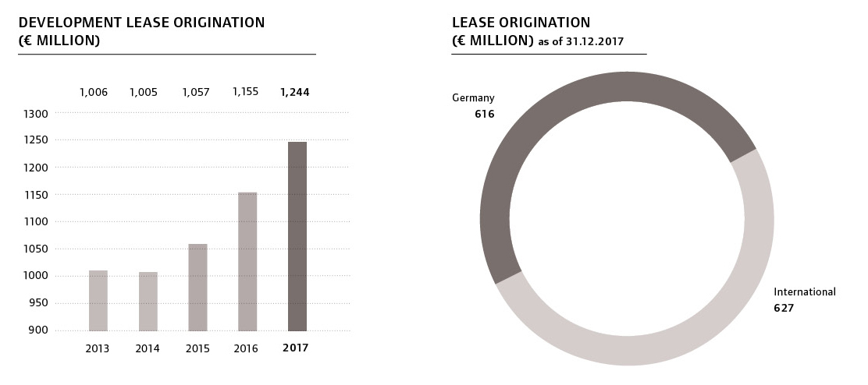

CHG-MERIDIAN: The Company
CHG-MERIDIAN is one of the world’s leading non-captive providers of technology management services to the IT, industrial, and healthcare sectors. With some 900 employees, CHG-MERIDIAN offers its customers comprehensive support for their technology infrastructure – from consulting, financial, and operational services to used-equipment remarketing services through its two technology and service centers in Germany and Norway. CHG-MERIDIAN provides efficient technology management to large, medium-sized, and small companies as well as government agencies. It now serves more than 10,000 customers worldwide, managing technology investments worth a total of over €4.6 billion. The online-based TESMA® Technology and Service Management System provides more than 15,000 users with maximum transparency in technology management. The Company has offices in 35 locations in 22 countries across the globe; its headquarters are in the southern German town of Weingarten.

